Map Messaging Tools In WorldEdit

Event Editor

Use the event editor to create event groups, which can be bound to messages on nodes.

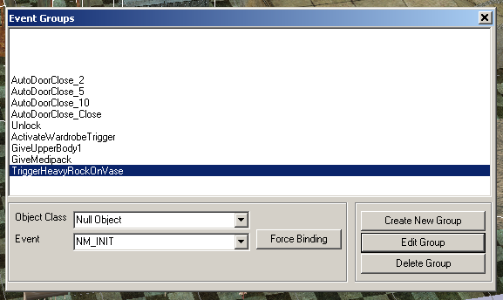

Options:-

Create New Group – Create and name a new group of events

Edit Group – Invokes the messaging editor for creating the messages and targets for this group.

Delete Group – Deletes the current group….

Force Binding – Binds current group to selected ‘event’ on all occurrence of ‘object class’. Be very very careful when using this. In fact, don’t use it at all….

Messaging Editor Screen

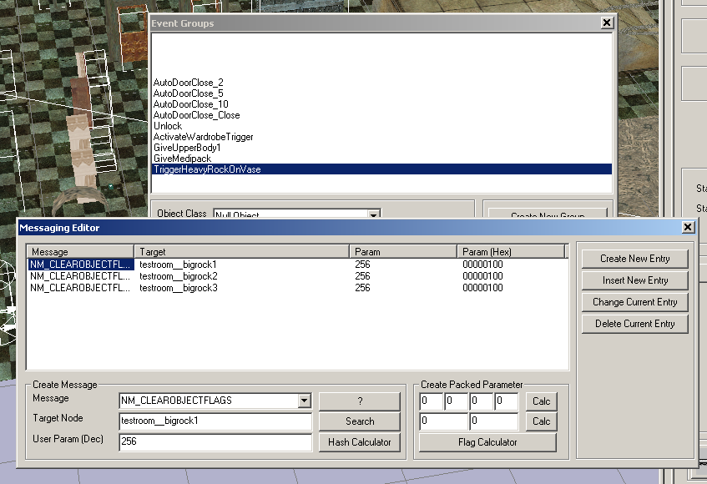

The messaging editor is used to edit message and target sequences. Messages are dispatched in the game starting with the topmost message.

Create New Entry – Adds the current working message (in the create message area) at the end of the message sequence.

Insert New Entry – Adds the current working message before the currently selected message.

Change Current Entry – Replaces the currently selected message with the current working message.

Delete Current Entry – Deletes the currently selected message.

Tools Within ‘Create Message’ Area

? – Shows description of selected message (or it will, maybe one day…)

Search – Invokes the node target search dialogue.

Hash Calculator – Invokes the ‘hash calculator’ dialogue.

Tools Within ‘Create Packed Parameter’ Area

This area is used for creating ‘multi value’ parameters for messages. To create a 4 value parameter, enter the values (between 0-255) in the four number boxes, and hit the Calc button to the right – this will create a four value parameter in the User Param field of the create message area. The same applies for two value parameters, except the values are in the range 0-65535.

Flag Calculator – This invokes the flag calculator dialog, which is used for creating parameters for NM_SETOBJECTFLAGS and NM_CLEAROBJECTFLAGS messages.

Hash Calculator Screen

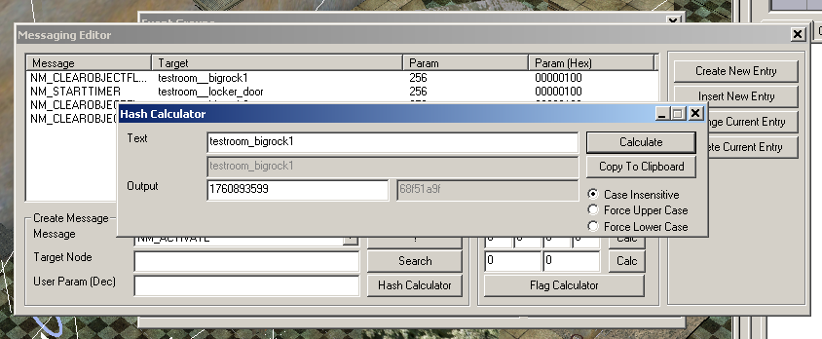

The hash calculator screen is used for calculating the hash value of text strings. A hash value is a 32 bit numeric representation of a piece of text – this provides a method for the game to reference named nodes, or FX templates, or event groups without having to store the text for the name. Hash values are often used in the parameter field of a message (eg NM_DISPATCHEVENTS – the parameter field is the hash value of the name of the event group to dispatch). When typing names in, enter them exactly as they appear in WorldEdit, and leave ‘Case Insensitive’ selected (it should read Case Sensitive, by the way – this will get fixed one day…).
Incidentally, hash values are also used for the ‘Target Node’ in the messaging editor, but the hash calculation is done behind the scenes.

Hash Calculator Tools

Calculate – Calculates the hash value of the currently entered text

Copy To Clipboard – Copies the output text to the clipboard, so it can be pasted (use Ctrl-v for speed!) into the ‘User Param (Dec)’ field of the messaging editor.

Flag Calculator Screen

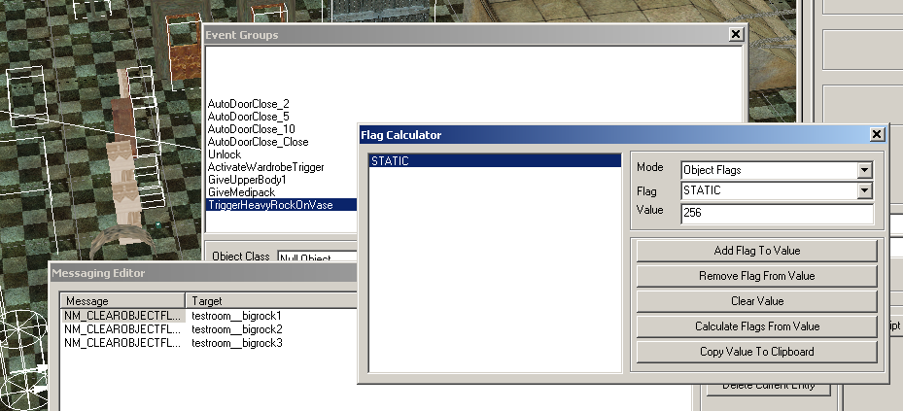

The flag calculator screen is used for calculating the ‘User Param’ field for NM_CLEAROBJECTFLAGS / NM_SETOBJECTFLAGS messages. Multiple flags can be set or cleared with one message – this tool calculates the numeric value to use from the flag combination you give it.

Add Flag To Value – Adds the flag in the ‘Flag’ combo box into the ‘Value’ field (this will become the ‘User Param’ field). The flag is also show in the window on the left, for handy reference.

Remove Flag From Value – Removes the flag in the ‘Flag’ combo box from the ‘Value’ field (and from the window on the left).

Clear Value – Clears all flags form value (sets it to 0)

Calculate Flags From Value – Shows all the flags selected in the ‘Value’ field. Useful for checking the values used in messages – paste the messages ‘User Param’ field into the ‘Value’ box, and hit this button.

Copy Value To Clipboard – Copies the ‘Value’ to the clipboard, so it can be pasted into the ‘User Param’ field of the messaging editor.

Event Binding Screen

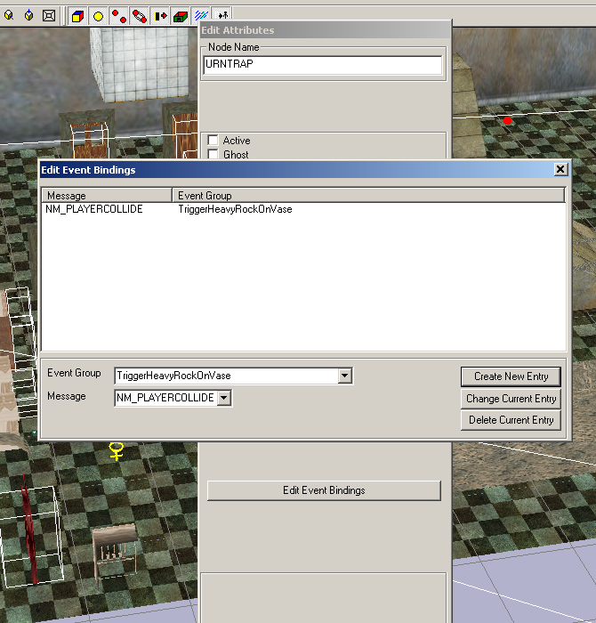

The event binding screen is accessed from the ‘Edit Attributes’ dialog on an object node (shift-click the object, then do ctrl-a). This dialog allows you to bind an event group to an object message, so that when the object receives the message, the events in the event group are dispatched.

Create New Entry – Creates a new binding – binds selected ‘Event Group’ to selected ‘Message’

Change Current Entry – Replaces the currently selected entry, with ‘Event Group’ and ‘Message’

Delete Current Entry – Deletes the currently selected entry.

